ASP206LP Light Pole
Light Pole for ASP Platforms
Specification Sheet
ASP206LP – Light Pole – Is designed to be easily attached to any ASP equipment or work platform. Each light pole is prewired and includes light fixture. Light Pole attaches directly to the platforms by bolting through the grating floor using 4 bolts 2-1/2” long with nuts provided. Each light pole can be manufactured to fit any size platform.

Materials

Light Poles: 2” Square Tubing, Gussets 1/4” plate welded to 8”X8”X1/4” flat plate with 4 holes drilled for bolting directly to the grating floor of the platforms. All steel hot dip galvanized after fabrication.

Hardware: 2-1 /2” X 1/2” bolts; 1/2” Nuts available in Hot-Dip Galvanized finish.

Accessories: On/On Switch; Dusk to Dawn Sensor; Timer; Light Bulbs not included

Installation:
- Verify that roof surface is smooth and clean to extent needed to receive materials.
- Review approved final drawings to determine the locations of Light Pole.
- Clean surfaces to receive Light Pole of any foreign matter before setting Light Pole.
- Accurately locate and align pre-fabricated Light Pole in locations specified as per approved shop drawings.
- Attach Light Pole to grating floor of platform floor using bolts and nuts provided.
- Repeat until all Light Poles supplied are installed in accordance with approved shop drawings.
- Remove any unused materials and packaging from job site.
This print/image and design and detail shown hereon is the property of Advanced Support Products, Inc. This print is furnished with the understanding that it is not to be reproduced without permission, and must be returned upon demand. All rights of design and invention are reserved by Advanced Support Products. Patents #5816554 ; #6229497; #6427965; #6448497; #6578827 © 2010
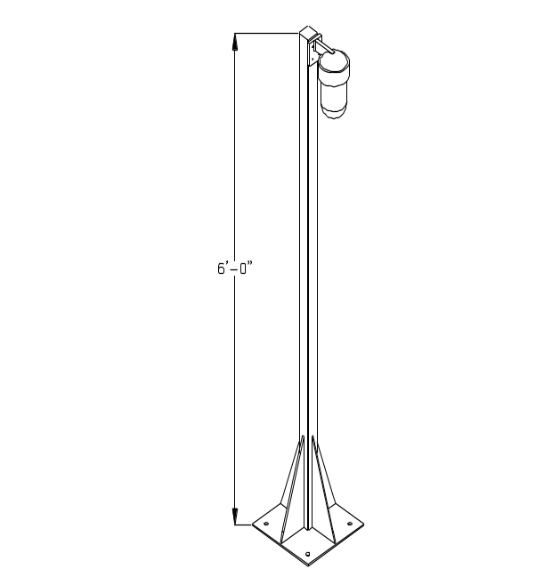
Standard Height: 6’0”
Weight as shown: 30 lbs.

